LABORATORY ASSIGNMENT 2025

**Cisco Packet Tracer (Routing and Switching – IPv4)**

**TASK 1**

**Creation of VLAN:**

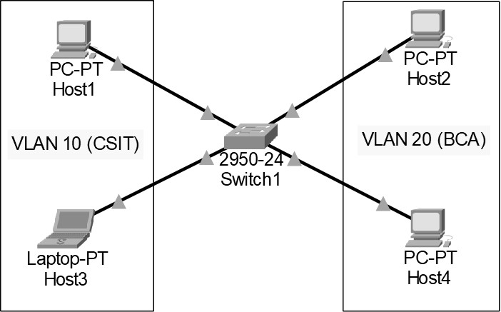

**Addressing Table**

|  |  |  |  |  |  |  |  |
| --- | --- | --- | --- | --- | --- | --- | --- |
| **Device** | **Interface** | **IPv4**  **Address** | **Subnet Mask** | **Switch Port** | **VLAN**  **No** | **VLAN**  **Name** | **Link** |
| Host1 | NIC | 172.17.10.21 | 255.255.255.0 | Fa0/1 | 10 | CSIT | Access |
| Host3 | NIC | 172.17.10.22 | 255.255.255.0 | Fa0/2 | 10 | CSIT | Access |
| Host2 | NIC | 172.17.10.23 | 255.255.255.0 | Fa0/11 | 20 | BCA | Access |
| Host4 | NIC | 172.17.10.24 | 255.255.255.0 | Fa0/12 | 20 | BCA | Access |

1. Design the given topology

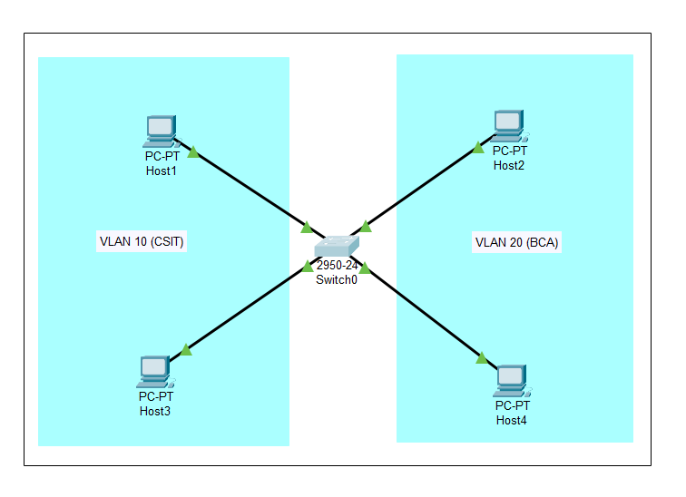

Components used:

* 1 Switch (2950-24)
* 4 PCs
* Copper Straight- Through wire for connection

1. Assign the Layer 3 address (IP address) to all hosts.

Host1:

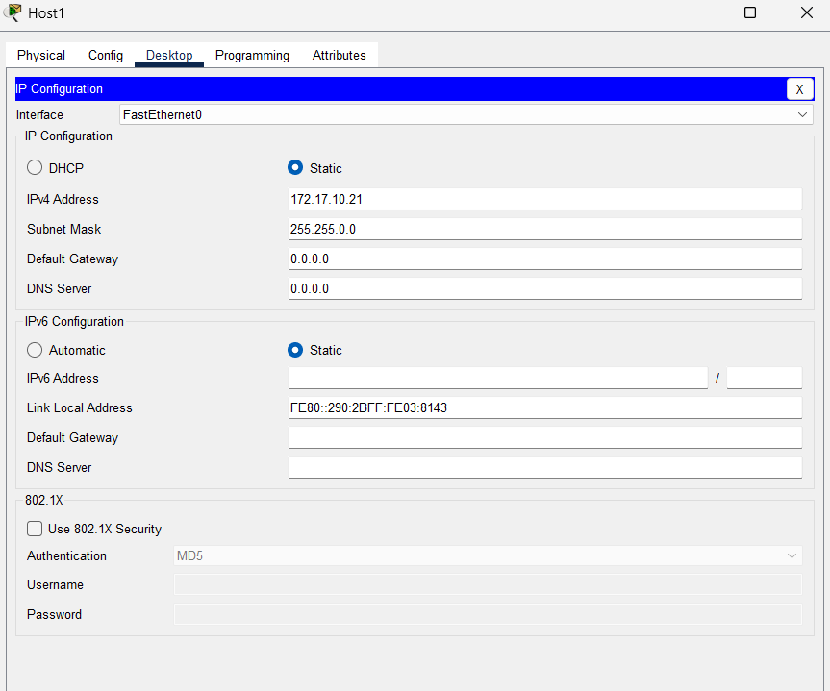

Host3:

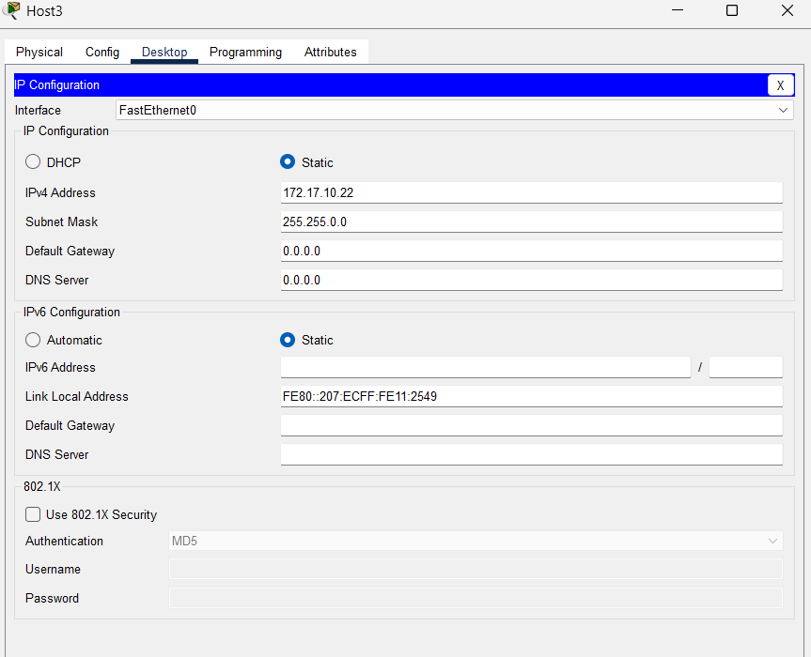

Host2:

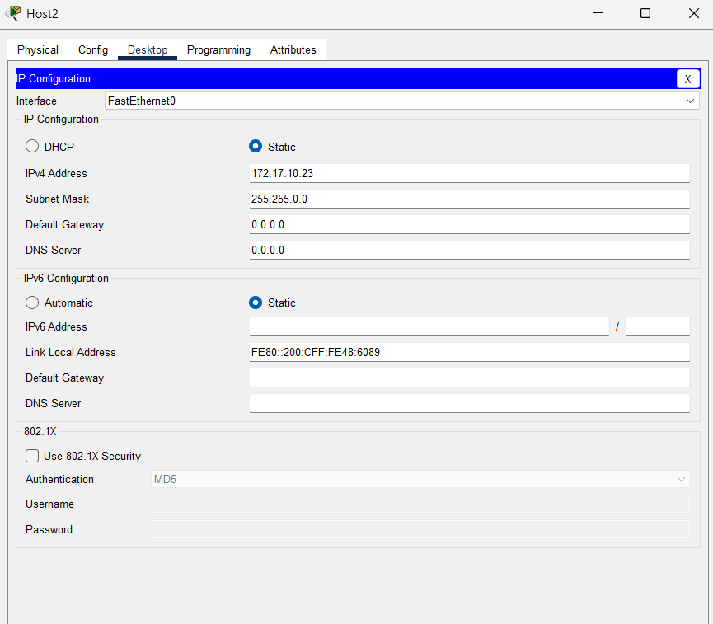

Host4:

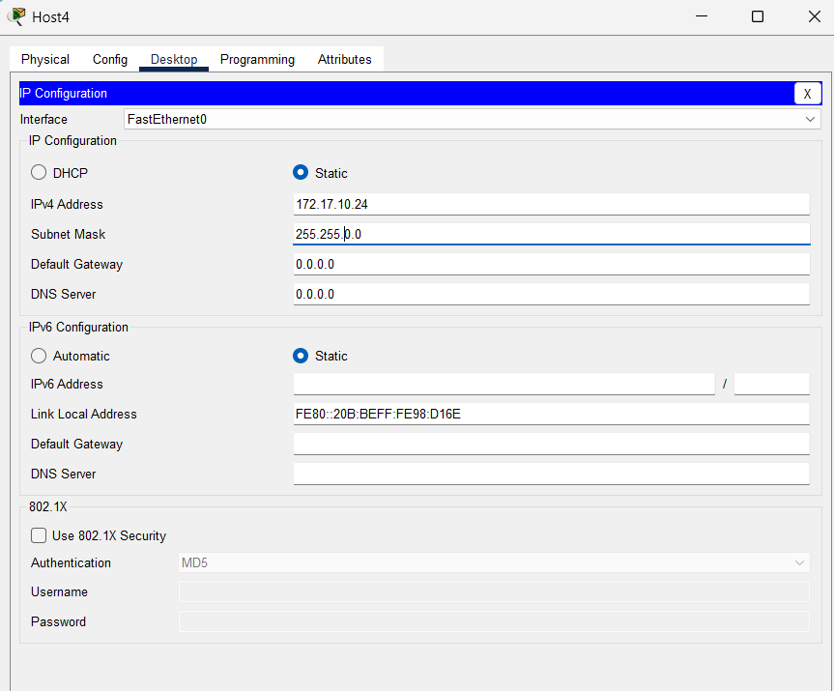

1. Configure the switch to create two VLANs

VLAN10 as CSIT

VLAN 20 as BCA

Switch0:

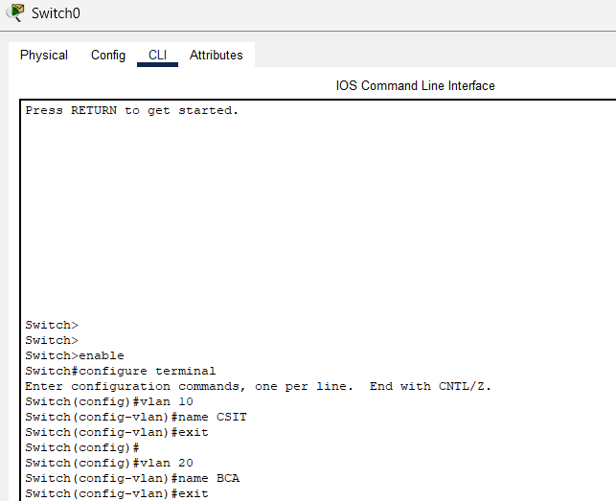

Assign VLANs to all the PC according to Addressing Table.

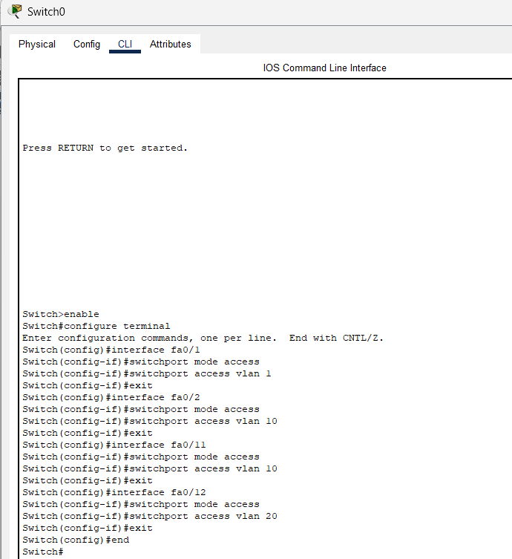

1. From the command prompt on each Host, do ping test between Hosts on the same and different VLAN and write the output.
2. Can Host1 ping Host3?

Answer:

No, Host1 cannot ping Host3

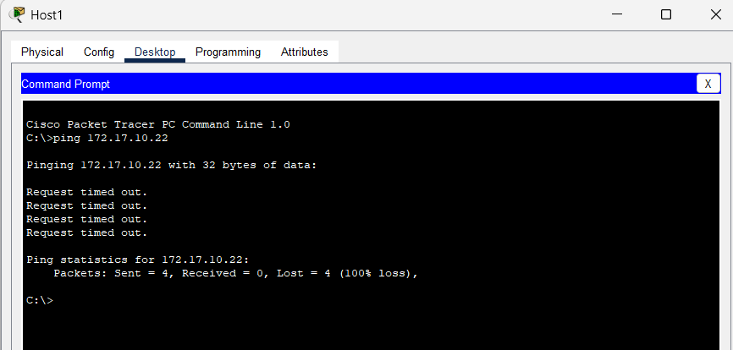

1. Can Host2 ping Host4?

Answer:

No, Host2 cannot ping Host4

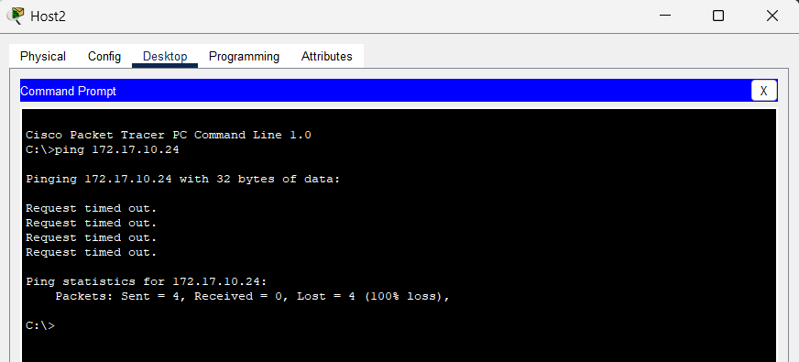

1. Can Host1 ping Host2 and Host4?

Answer:

No, Host1 cannot ping Host2 and Host4

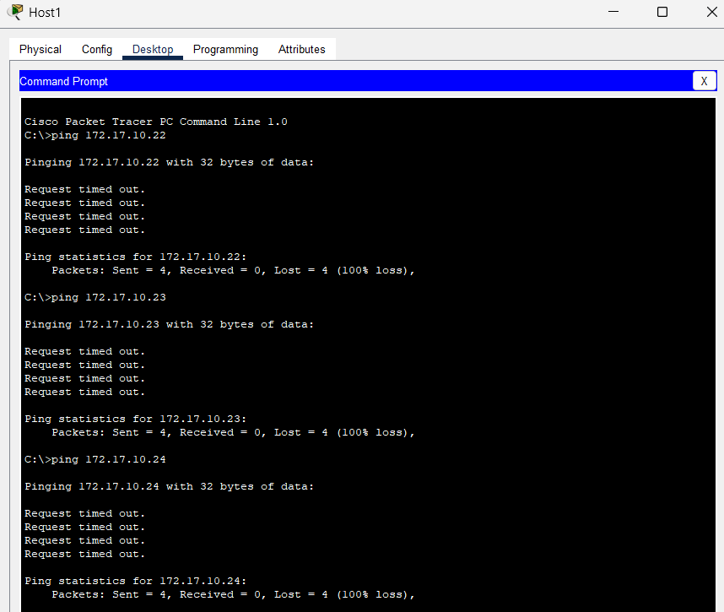

1. Can Host2 ping Host1 and Host3?

Answer:

No, host2 cannot ping Host1.

Yes, host2 can ping Host3.

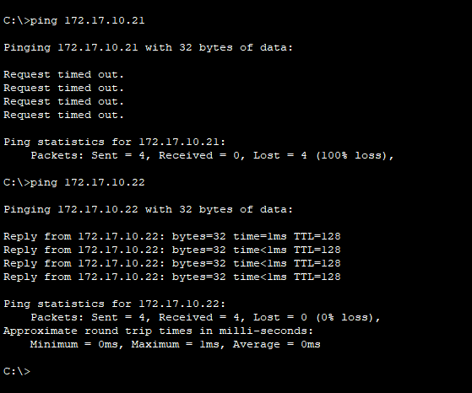

**TASK 2**

**Creation of VLAN Trunking:**

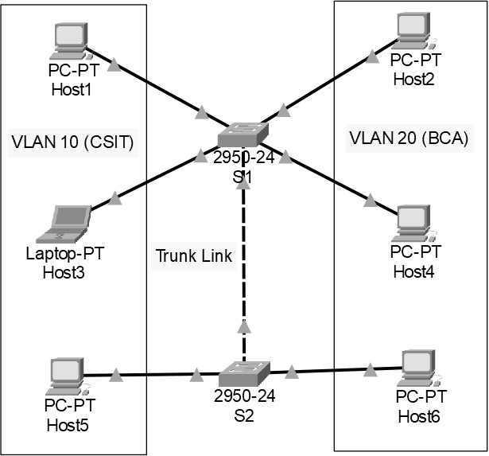

**Addressing Table**

|  |  |  |  |  |  |  |  |
| --- | --- | --- | --- | --- | --- | --- | --- |
| **Device** | **Interface** | **IPv4**  **Address** | **Subnet Mask** | **Switch Port** | **VLAN**  **No** | **VLAN**  **Name** | **Link** |
| Host1 | NIC | 172.17.10.21 | 255.255.255.0 | S1;  Fa0/1 | 10 | CSIT | Access |

|  |  |  |  |  |  |  |  |
| --- | --- | --- | --- | --- | --- | --- | --- |
| Host3 | NIC | 172.17.10.22 | 255.255.255.0 | S1;  Fa0/2 | 10 | CSIT | Access |
| Host2 | NIC | 172.17.10.23 | 255.255.255.0 | S1;  Fa0/11 | 20 | BCA | Access |
| Host4 | NIC | 172.17.10.24 | 255.255.255.0 | S1;  Fa0/12 | 20 | BCA | Access |
| Host5 | NIC | 172.17.10.25 | 255.255.255.0 | S2;  Fa0/3 | 10 | CSIT | Access |
| Host6 | NIC | 172.17.10.26 | 255.255.255.0 | S2;  Fa0/13 | 20 | BCA | Access |
| S1 | Fa0/24 | - | - | S2;  Fa0/24 |  |  | Trunk |

1. Design the given topology

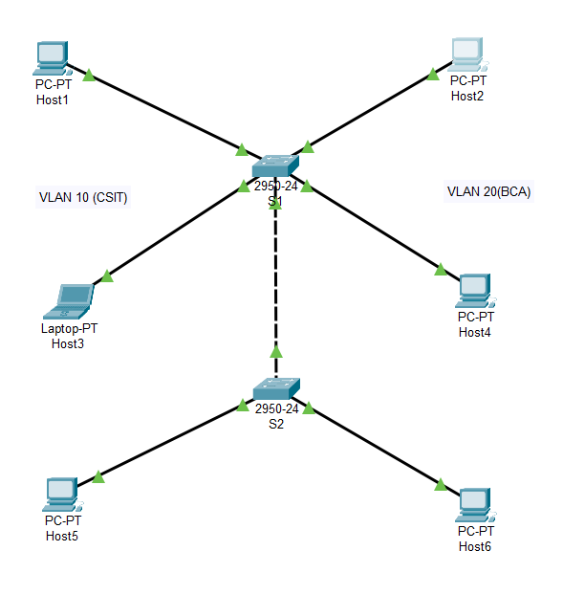

Components Used:

* 2 Switches (2950-24): S1, S2
* 6 PCs as Hosts
* Copper Straight- Through wire for connection between Switch and Hosts
* Copper Cross- Over wire for connection between two Switches

1. Assign the Layer 3 address (IP address) to all hosts.

Host1:

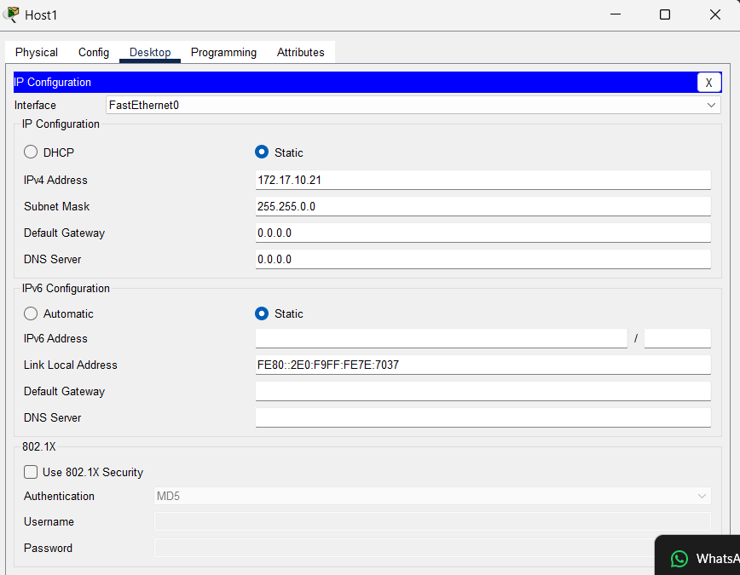

Host3:

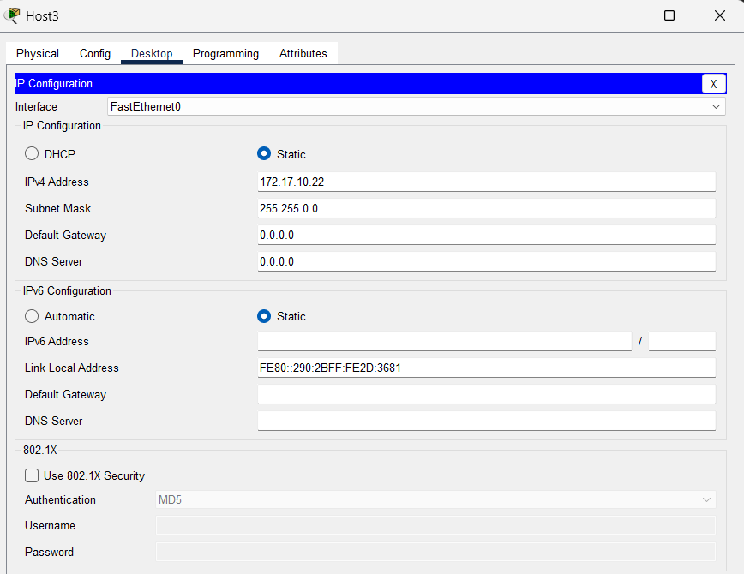

Host2:

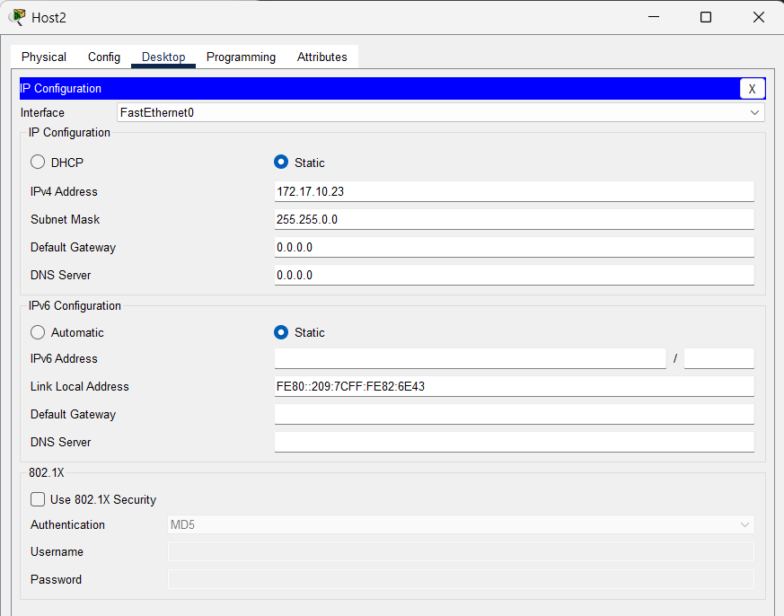

Host4:

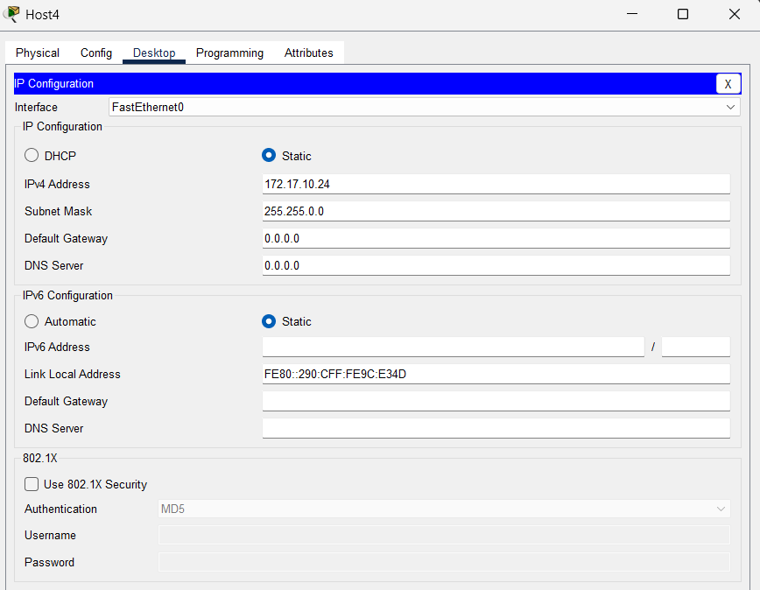

Host5:

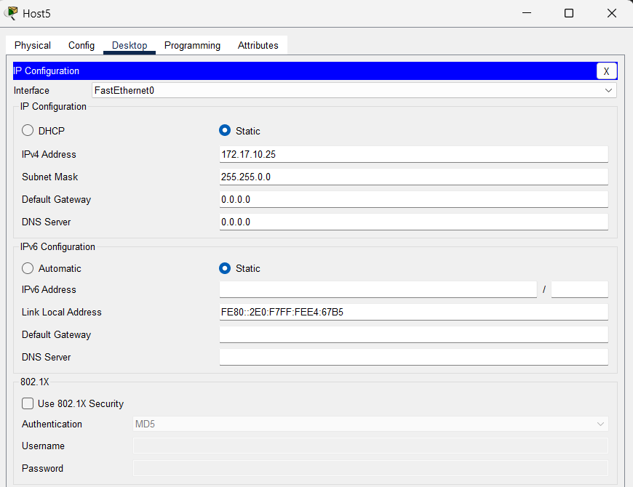

Host6:

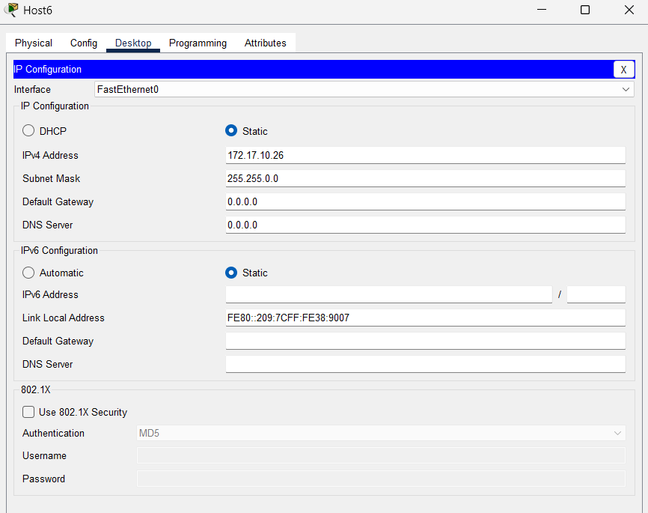

1. Configure the switch S1 and S2 to create two VLANs in each.

VLAN10 as CSIT

VLAN 20 as BCA

S1> CLI:

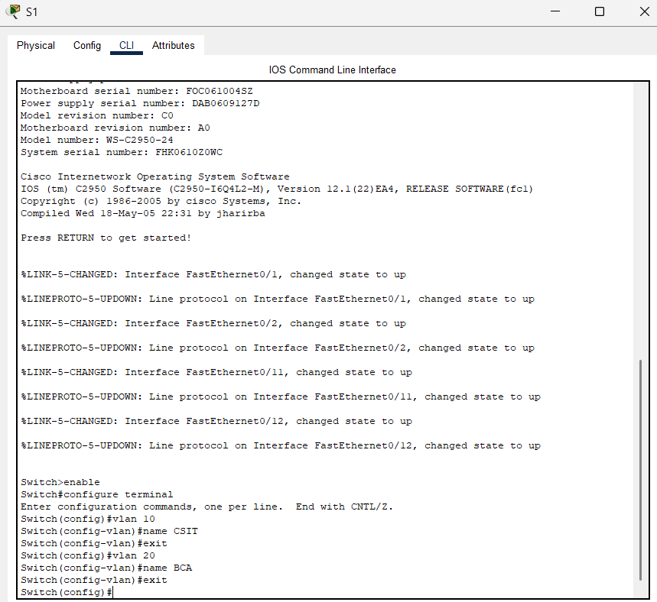

S2:

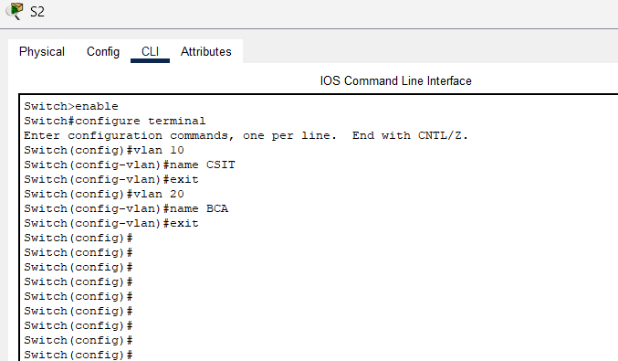

1. Assign VLANs to all the PC according to Addressing Table.

S1> CLI:

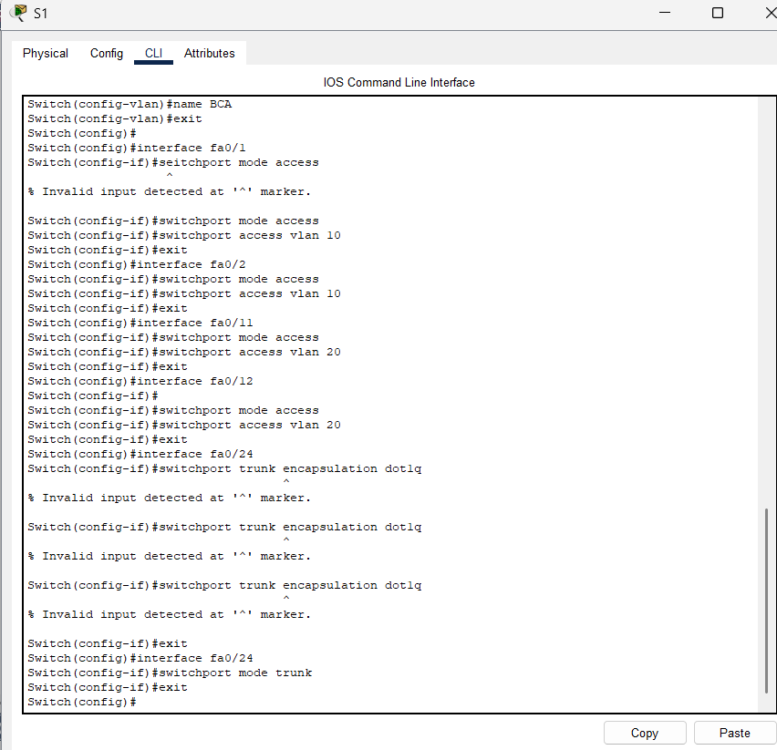

S2> CLI:

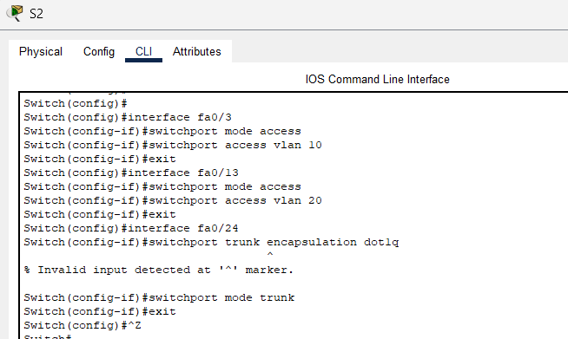

1. From the command prompt on each Host, do ping test between Hosts on the same and different VLAN and write the output.
2. Can Host1 ping Host3 and Host5?

Answer:

Yes, Host1 can ping Host3.

Yes, Host1 can ping Host5.

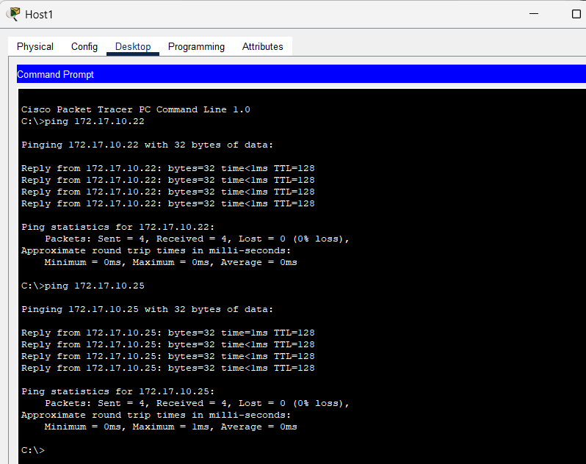

1. Can Host2 ping Host4 and Host6?

Answer:

Yes, Host2 can ping Host4.

Yes, Host2 can ping Host6.

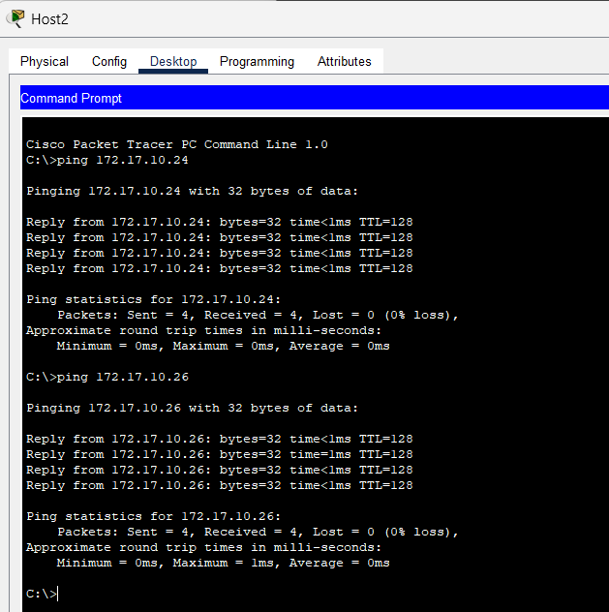

1. Can Host6 ping Host1?

Answer:

No, Host6 cannot ping Host1.

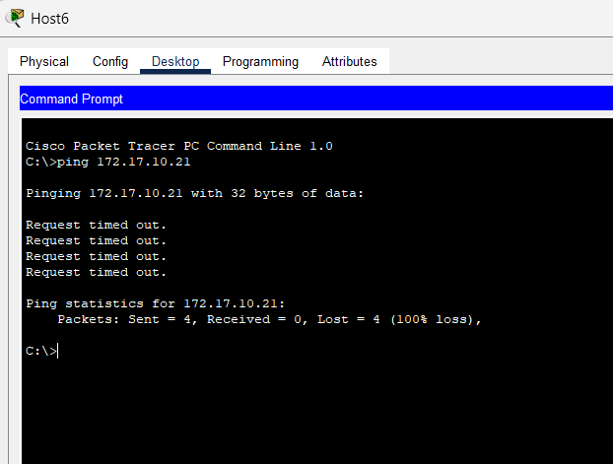

1. Can Host5 ping Host4?

Answer:

No, Host5 cannot ping Host4.

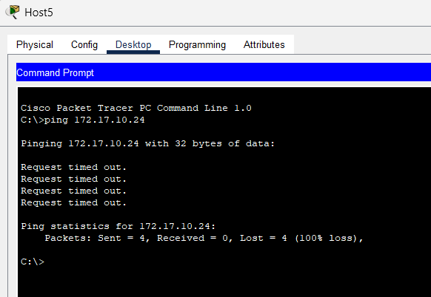

**TASK 3**



**Static Routing Implementation:**

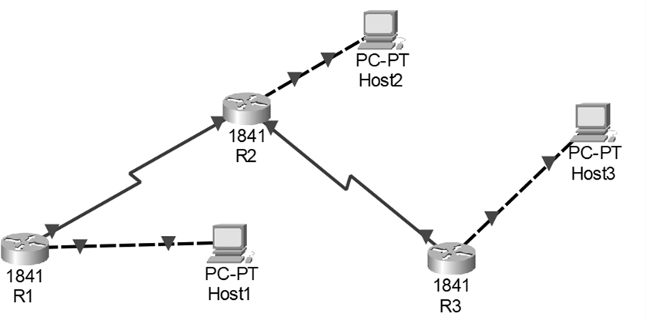

**Addressing Table**

|  |  |  |  |  |  |
| --- | --- | --- | --- | --- | --- |
| **Device** | **Interface** | **IPv4 Address** | **Subnet Mask** | **Gateway** | **Link Ports** |
| Host1 | NIC | 172.16.3.100 | 255.255.255.0 | 172.16.3.1 | R1;  fa0/0 |
| Host2 | NIC | 172.16.1.100 | 255.255.255.0 | 172.16.1.1 | R2;  fa0/0 |
| Host3 | NIC | 192.168.2.100 | 255.255.255.0 | 192.168.2.1 | R3;  fa0/0 |
| R1 | fa0/0 | 172.16.3.1 | 255.255.255.0 |  |  |
| se 0/0/0 | 172.16.2.1 | 255.255.255.0 |  | R2; se 0/0/0 |
| R2 | fa0/0 | 172.16.1.1 | 255.255.255.0 |  |  |
| se 0/0/0 | 172.16.2.2 | 255.255.255.0 |  | R1; se 0/0/0 |
| se 0/0/1 | 192.168.1.1 | 255.255.255.0 |  | R3; se 0/0/0 |
| R3 | fa0/0 | 192.168.2.1 | 255.255.255.0 |  |  |

|  |  |  |  |  |  |
| --- | --- | --- | --- | --- | --- |
| R3 | fa0/0 | 192.168.2.1 | 255.255.255.0 |  |  |
| se 0/0/0 | 192.168.1.2 | 255.255.255.0 |  | R2; se 0/0/1 |

Design the given topology

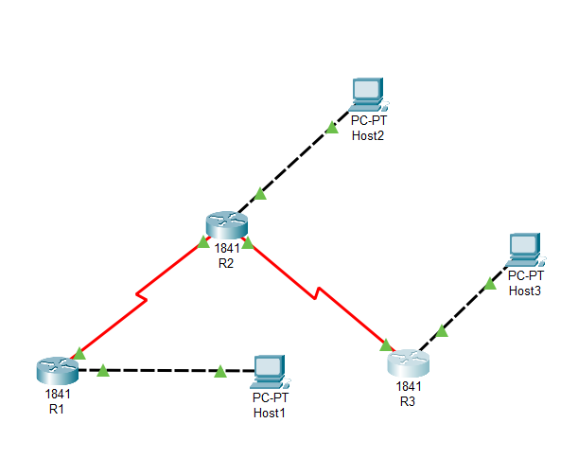

Assign the IP address to all hosts and Routers according to Addressing Table

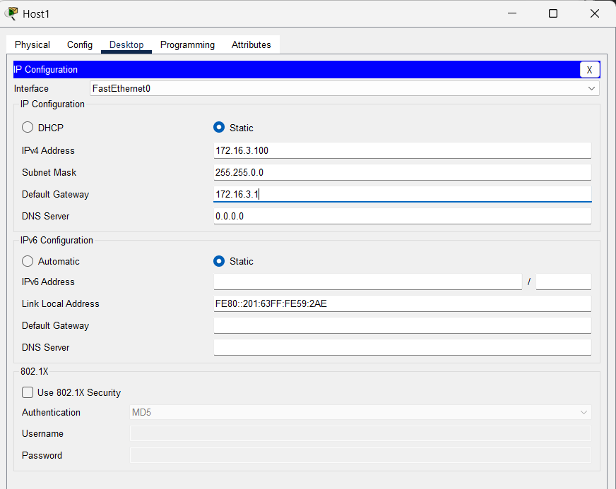

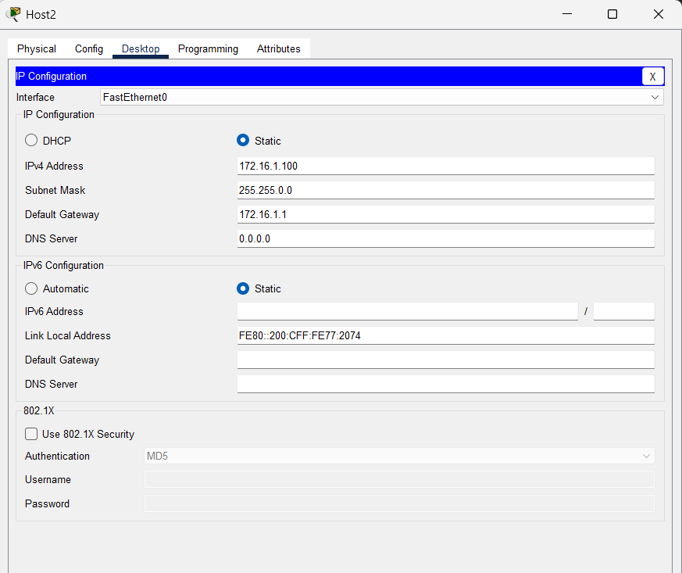

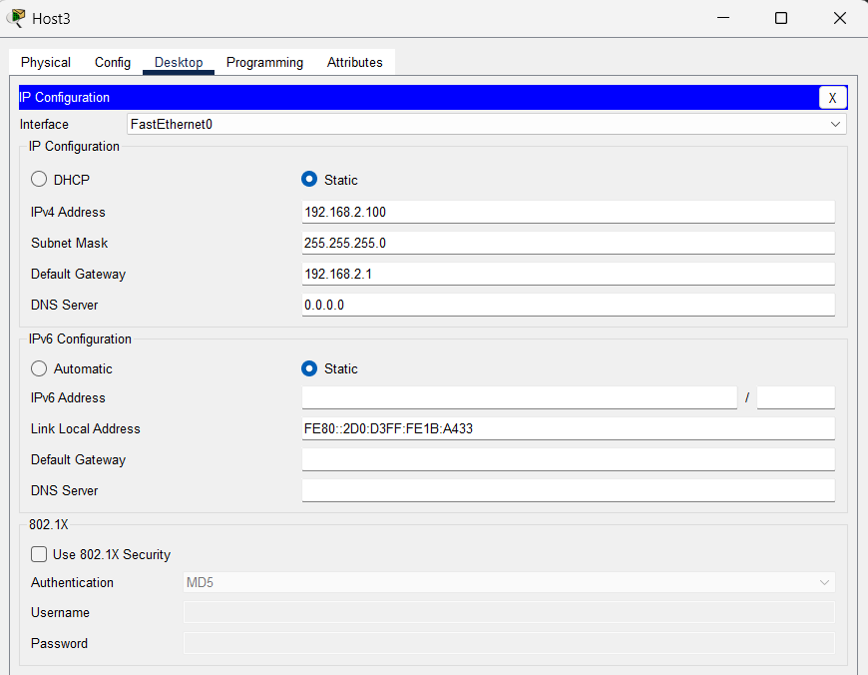

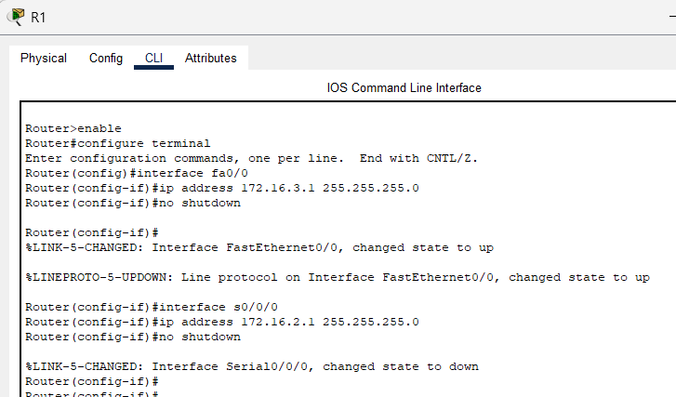

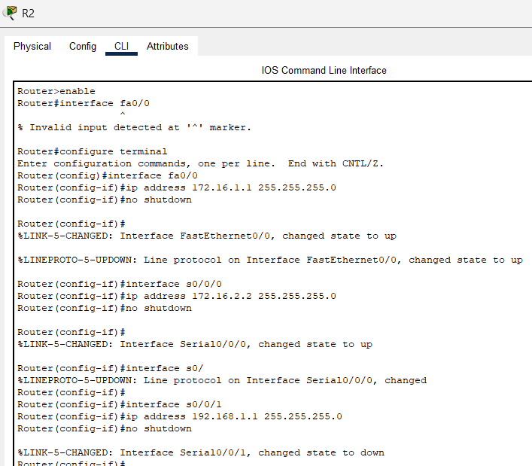

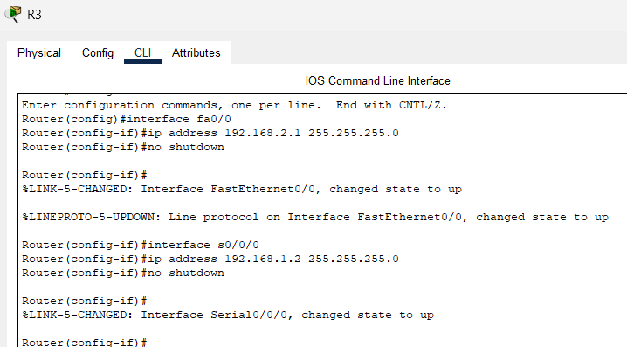

Configure the routers with static route.

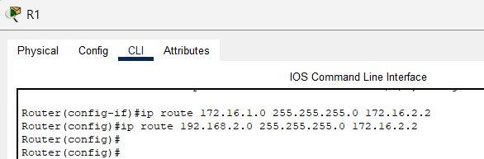

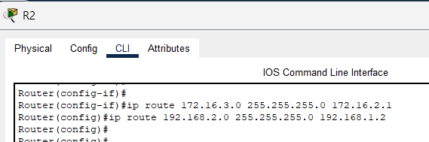

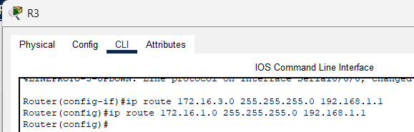

From the command prompt on each host, ping between hosts. Write the output.

Can Host1 ping Host2 and Host3?

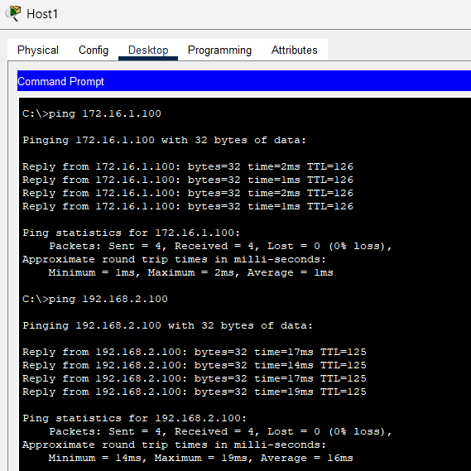

Can router R1 ping router Host3?

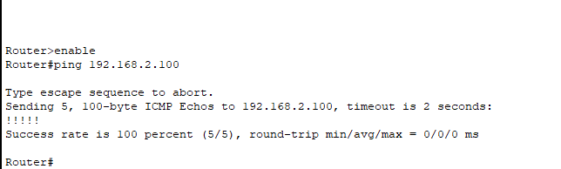

Can Host2 ping router R1 and Host3?

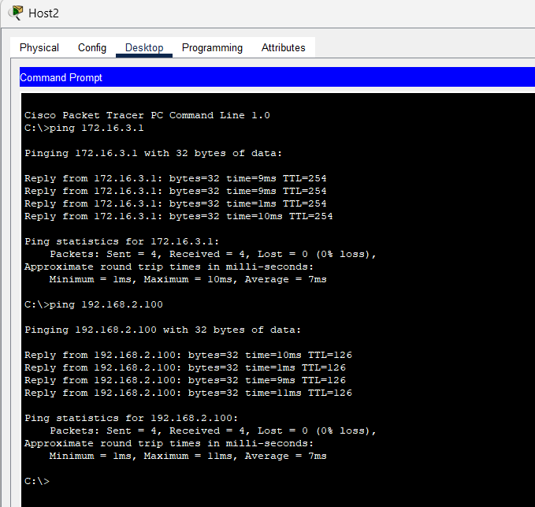

**TASK 4**

Routing Information protocol (RIP) Implementation:

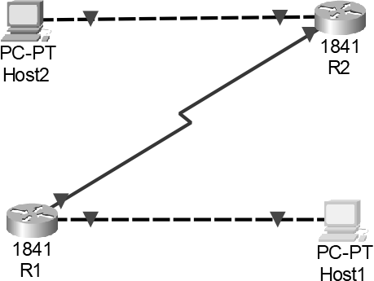

**Addressing Table**

|  |  |  |  |  |  |
| --- | --- | --- | --- | --- | --- |
| **Device** | **Interface** | **IPv4**  **Address** | **Subnet Mask** | **Gateway** | **Link Ports** |
| Host1 | NIC | 172.16.3.10 | 255.255.0.0 | 172.16.3.1 | R1; fa0/0 |

|  |  |  |  |  |  |
| --- | --- | --- | --- | --- | --- |
| Host2 | NIC | 172.18.1.10 | 255.255.255.0 | 172.18.1.1 | R2; fa0/0 |
| R1 | fa0/0 | 172.16.3.1 | 255.255.0.0 |  |  |
| se 0/0/0 | 172.17.2.1 | 255.255.255.252 |  | R2; se 0/0/0 |
| R2 | fa0/0 | 172.18.1.1 | 255.255.255.0 |  |  |
| se 0/0/0 | 172.17.2.2 | 255.255.255.252 |  | R1; se 0/0/0 |

Design the given topology

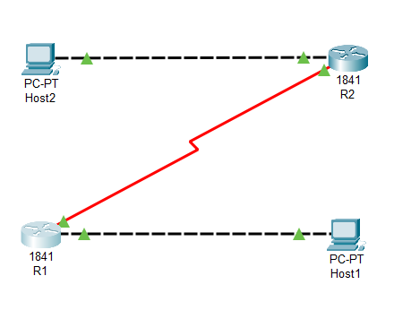

Assign the IP address to all PCs and Routers according to Addressing Table

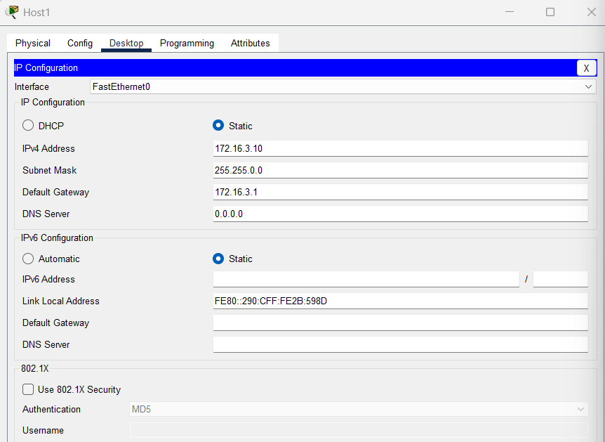

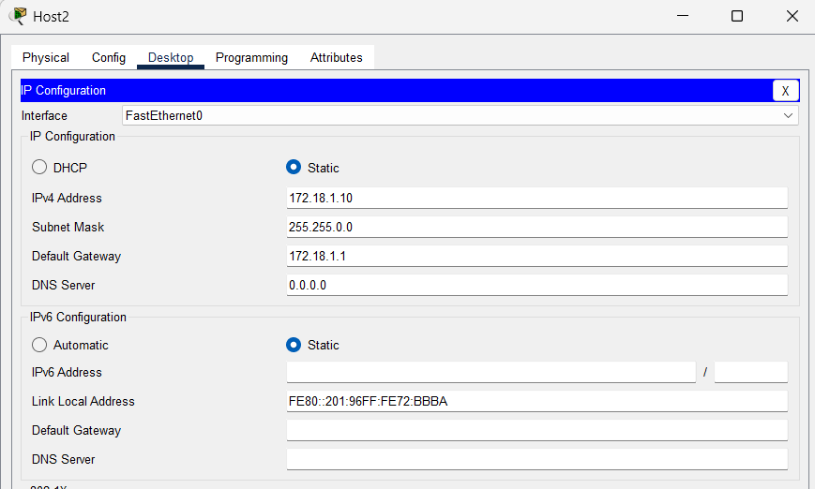

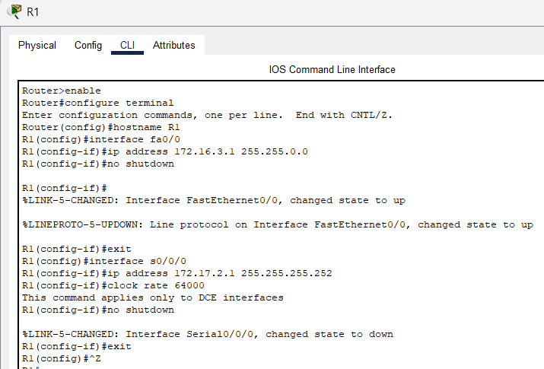

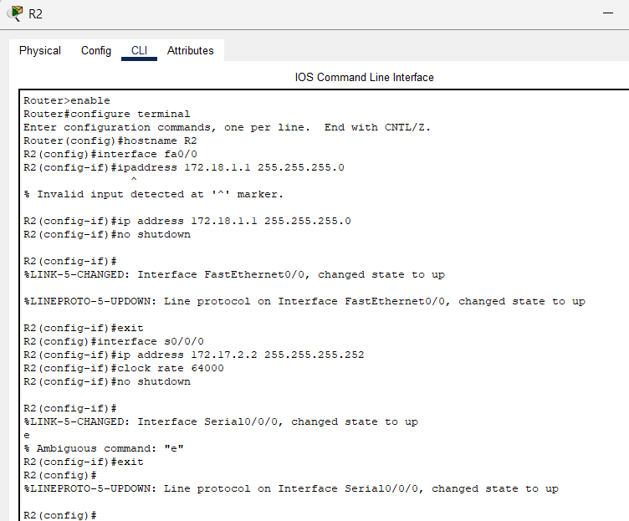

Configure the routers with RIPv2.

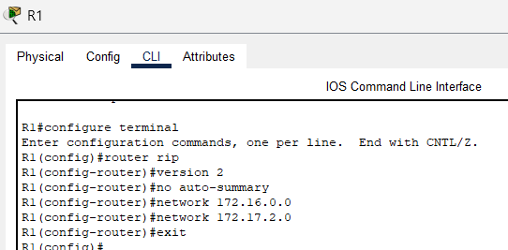

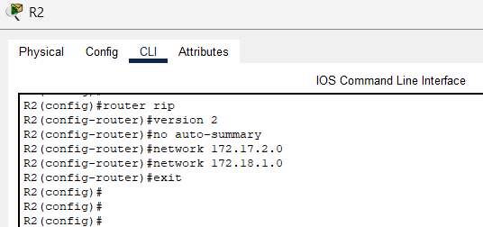

From the command prompt on each host, ping between hosts and routers. Write the output.

Can host1 ping host2?

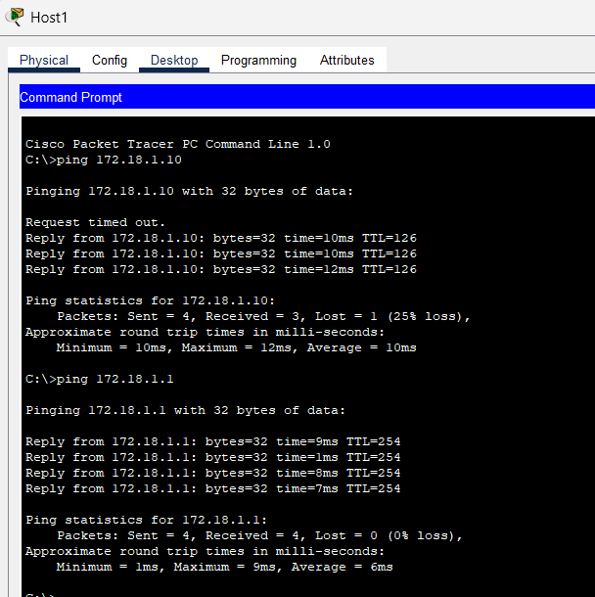

Can router R1 ping router R2?

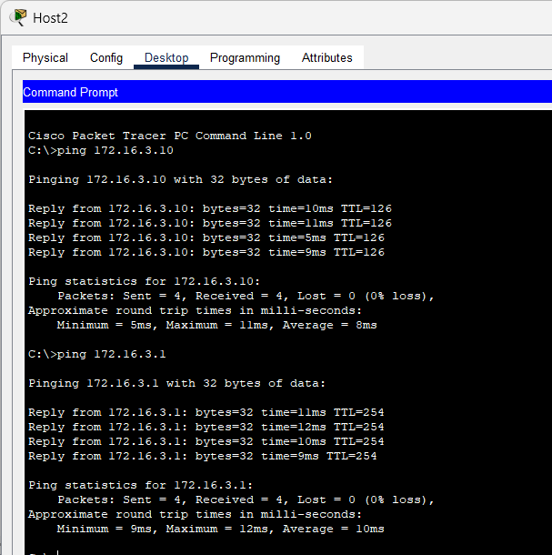

Can host2 ping router R1?

